**`**

CAPSTONE PROJECT  
Cloud Devops Final Project - Infrastructure Deployment

The document has two sections:

Cloud Formation scripts & Setup Kubernetes cluster on each of the EC2 Instances

Section 1 describes the Cloud Formation scripts used to deploy the EC2 instances for the Blue and Green Deployment.

Section 2 of the document explains how to setup and configure a Kubernetes cluster.

1. **CLOUD FORMATION SCRIPTS:**

Setup GitHub repository (branch) called Cloudformation-setup. This is a sub-branch under the master branch

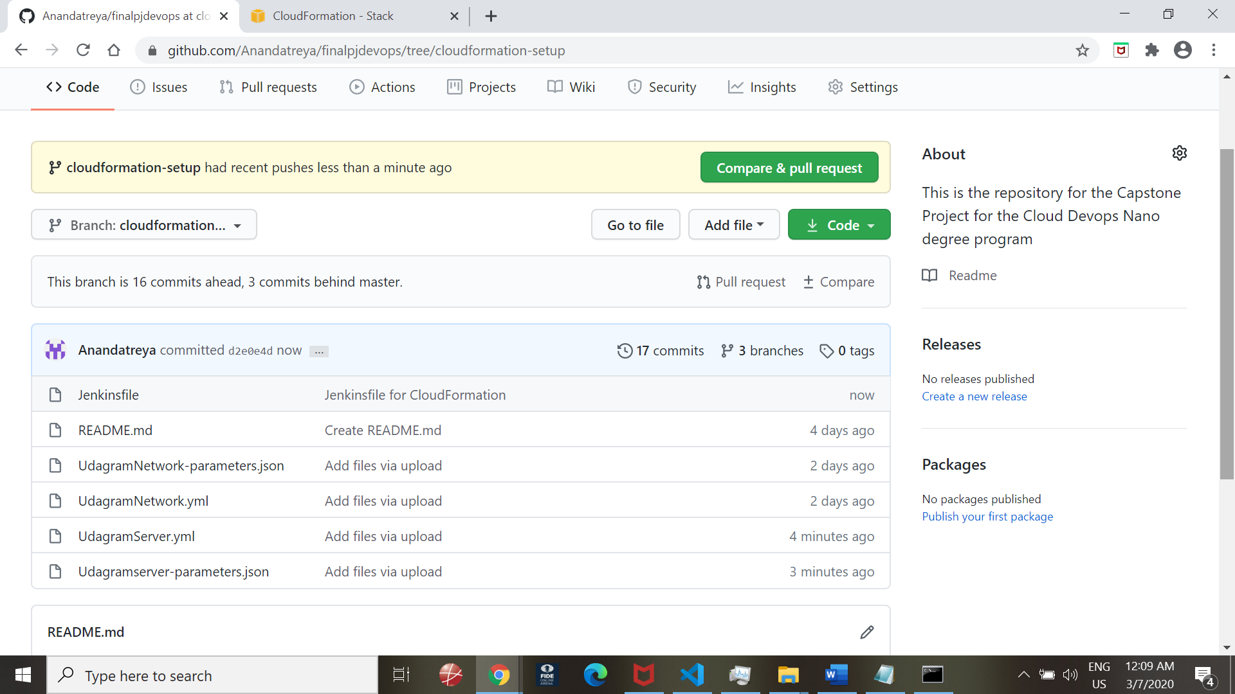

Cloudformation script will have two parameter files:

UdagramServer.yml - Configuration file

Udagramserver-parametes.json – Parameters file

View of the Build job in Jenkins:

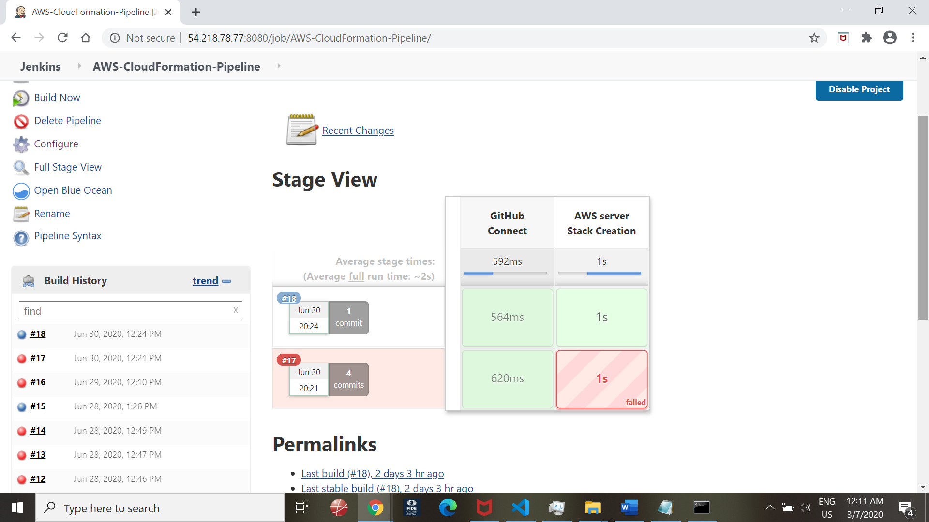

Succcessful Stack Creation:

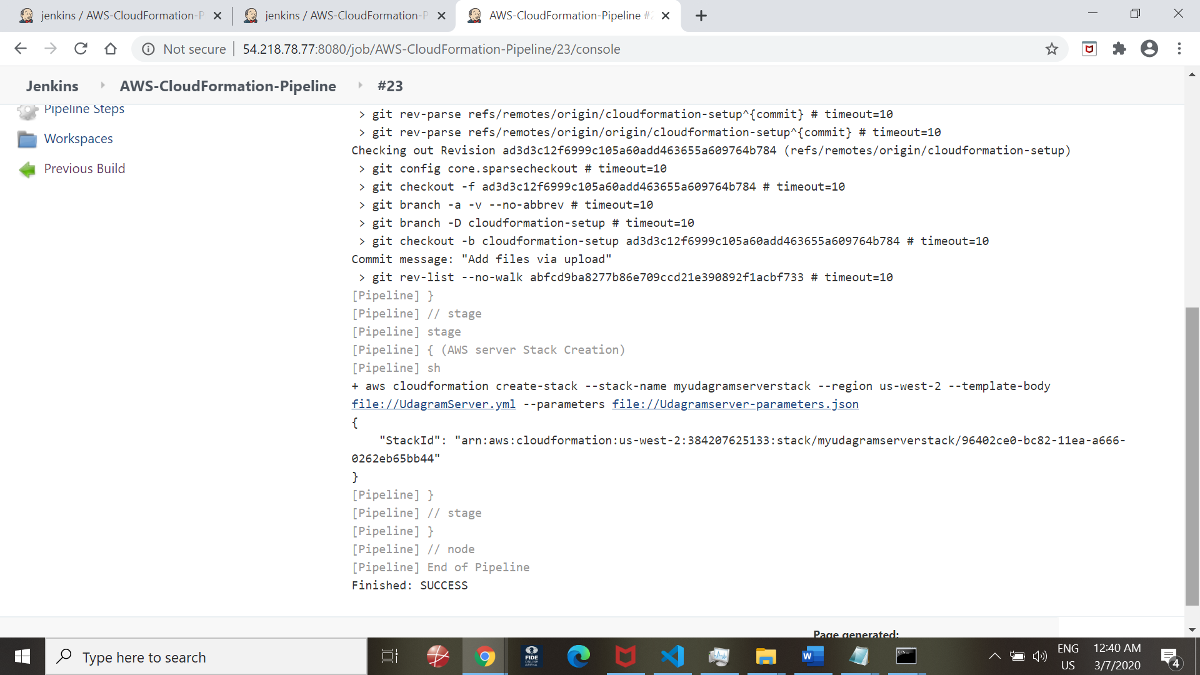

BlueOcean Workflow View:

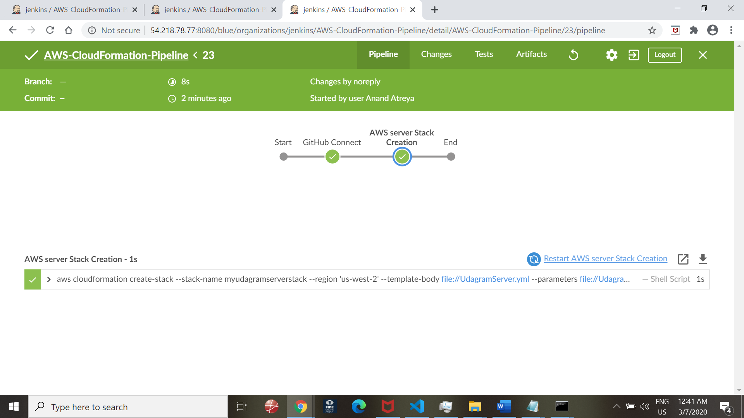

**Cloudformation View:**

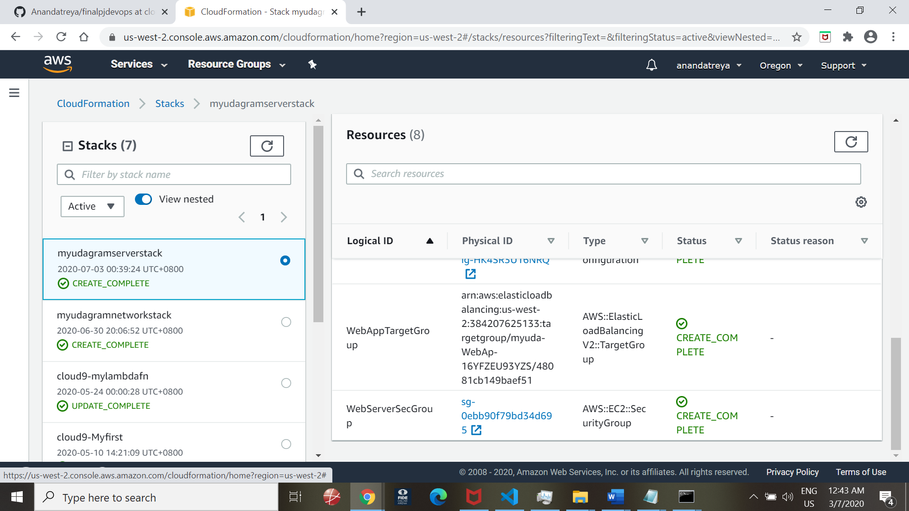

Ec2 Instance View:

Created a 2 servers under a Load Balancer

Named server as : Blue_Deployment and Green_Deployment

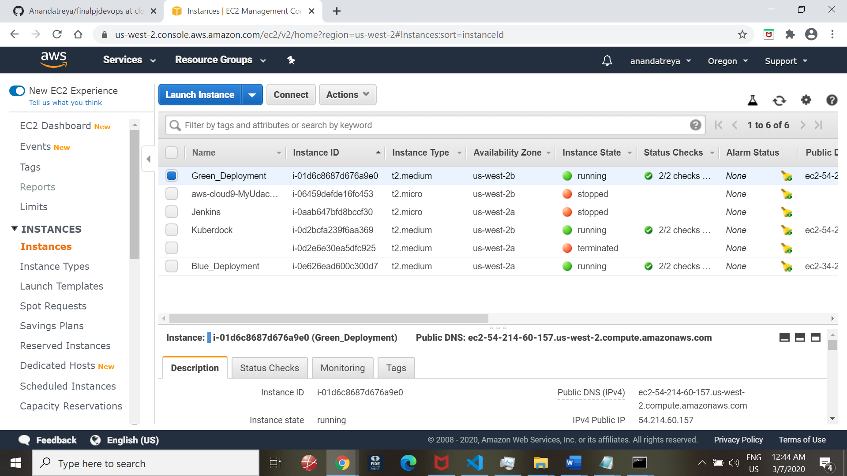

1. **Setup Kubernetes cluster on each of the Instances**

Login to Blue Server console:

Run Minikube initialisation commands:

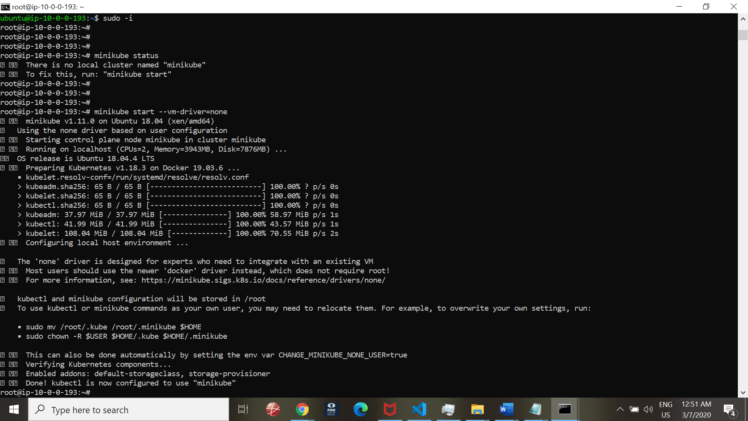

Minikube status is running on Blue Deployment server:

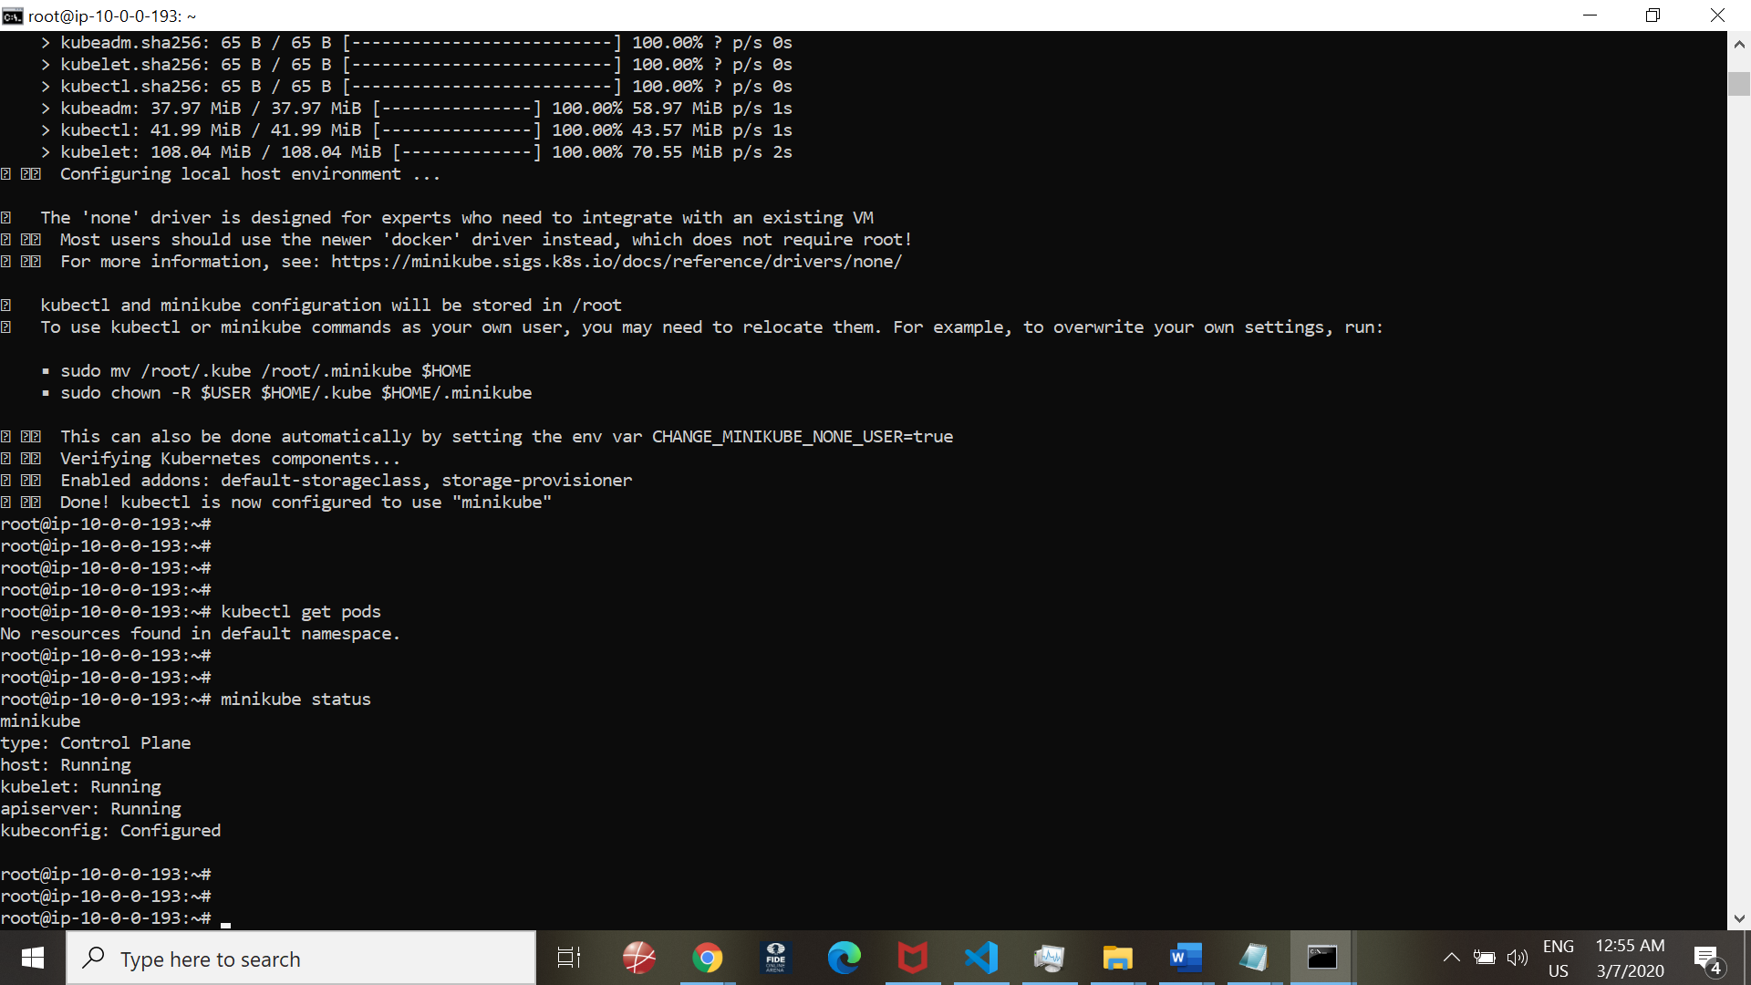

Other kubectl commands:

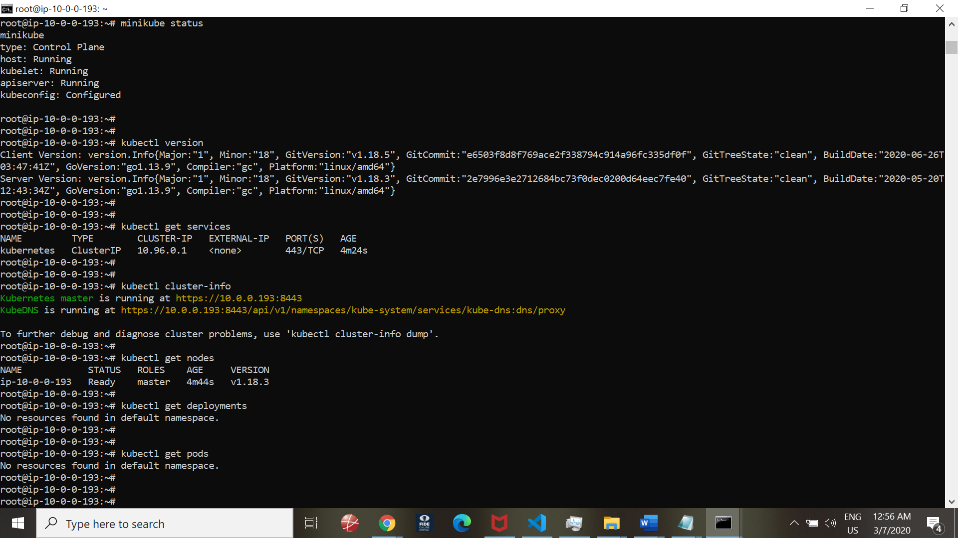

Docker commands and checks:

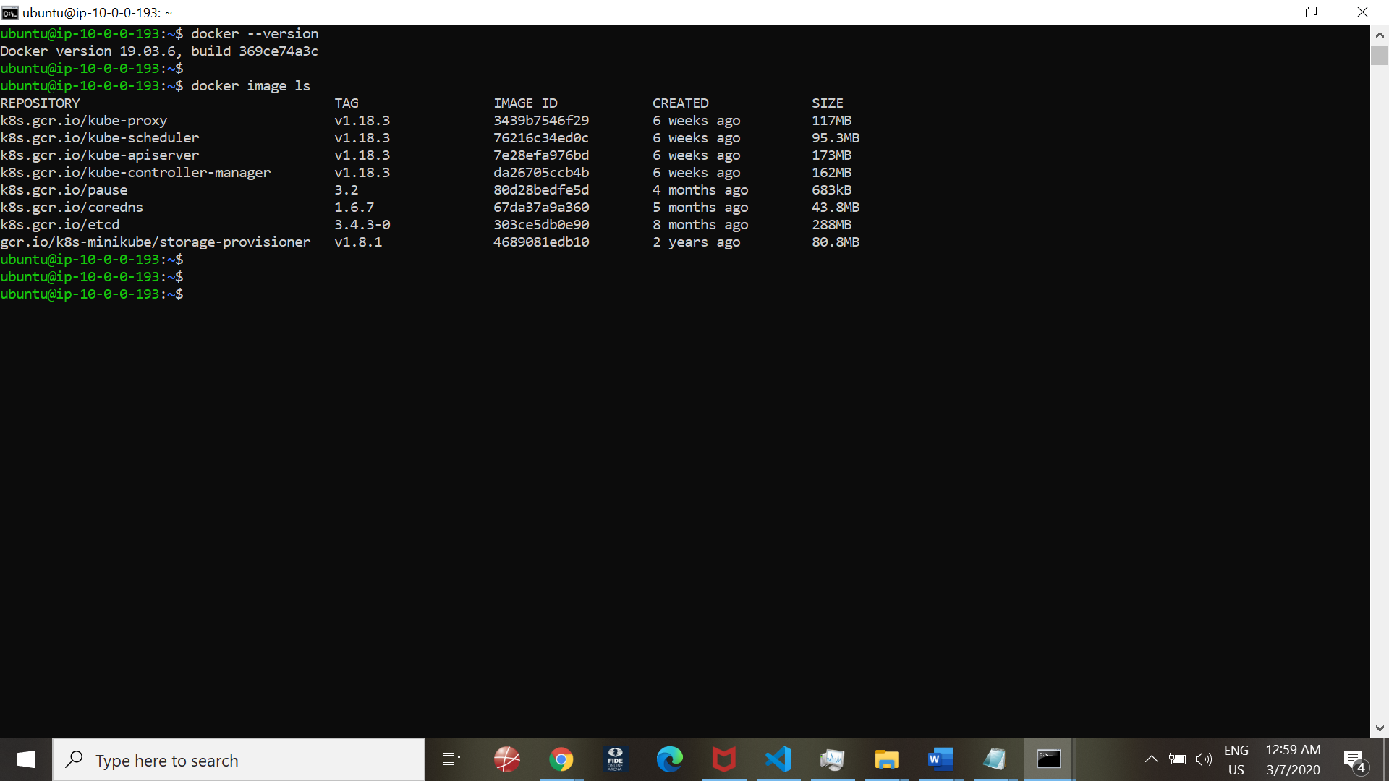

Do same checks for Green Deployment server

Start minikube cluster service

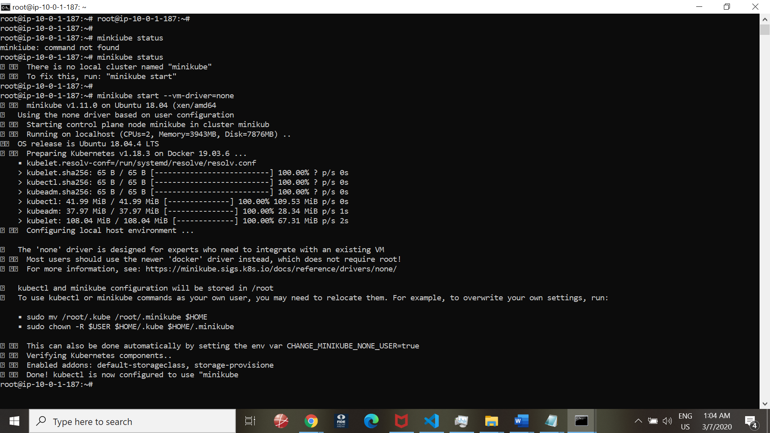

Verify minikube status

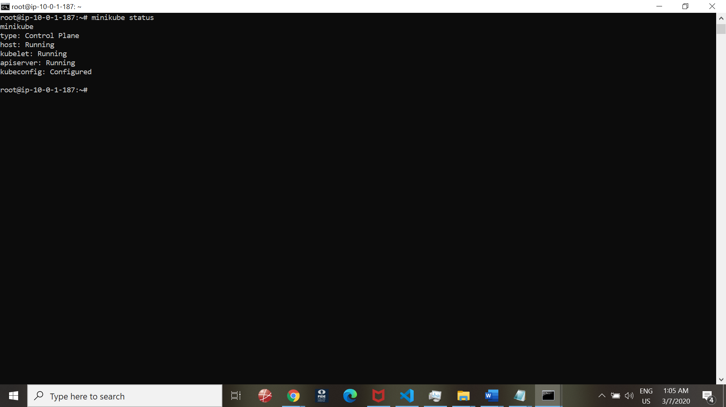

Check status of cluster and commands:

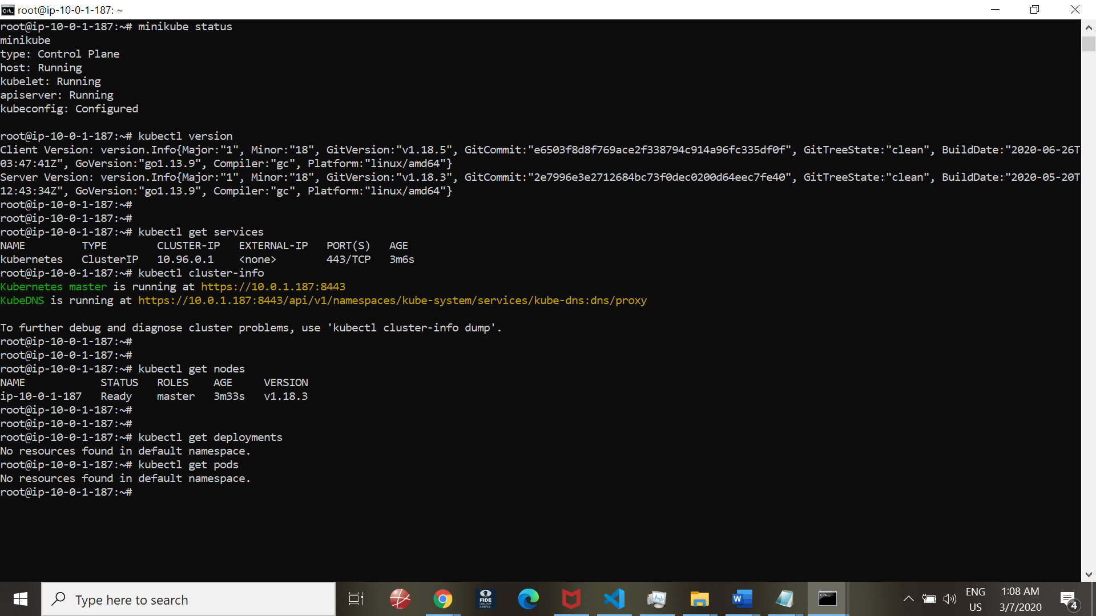

Check Docker version and commands:

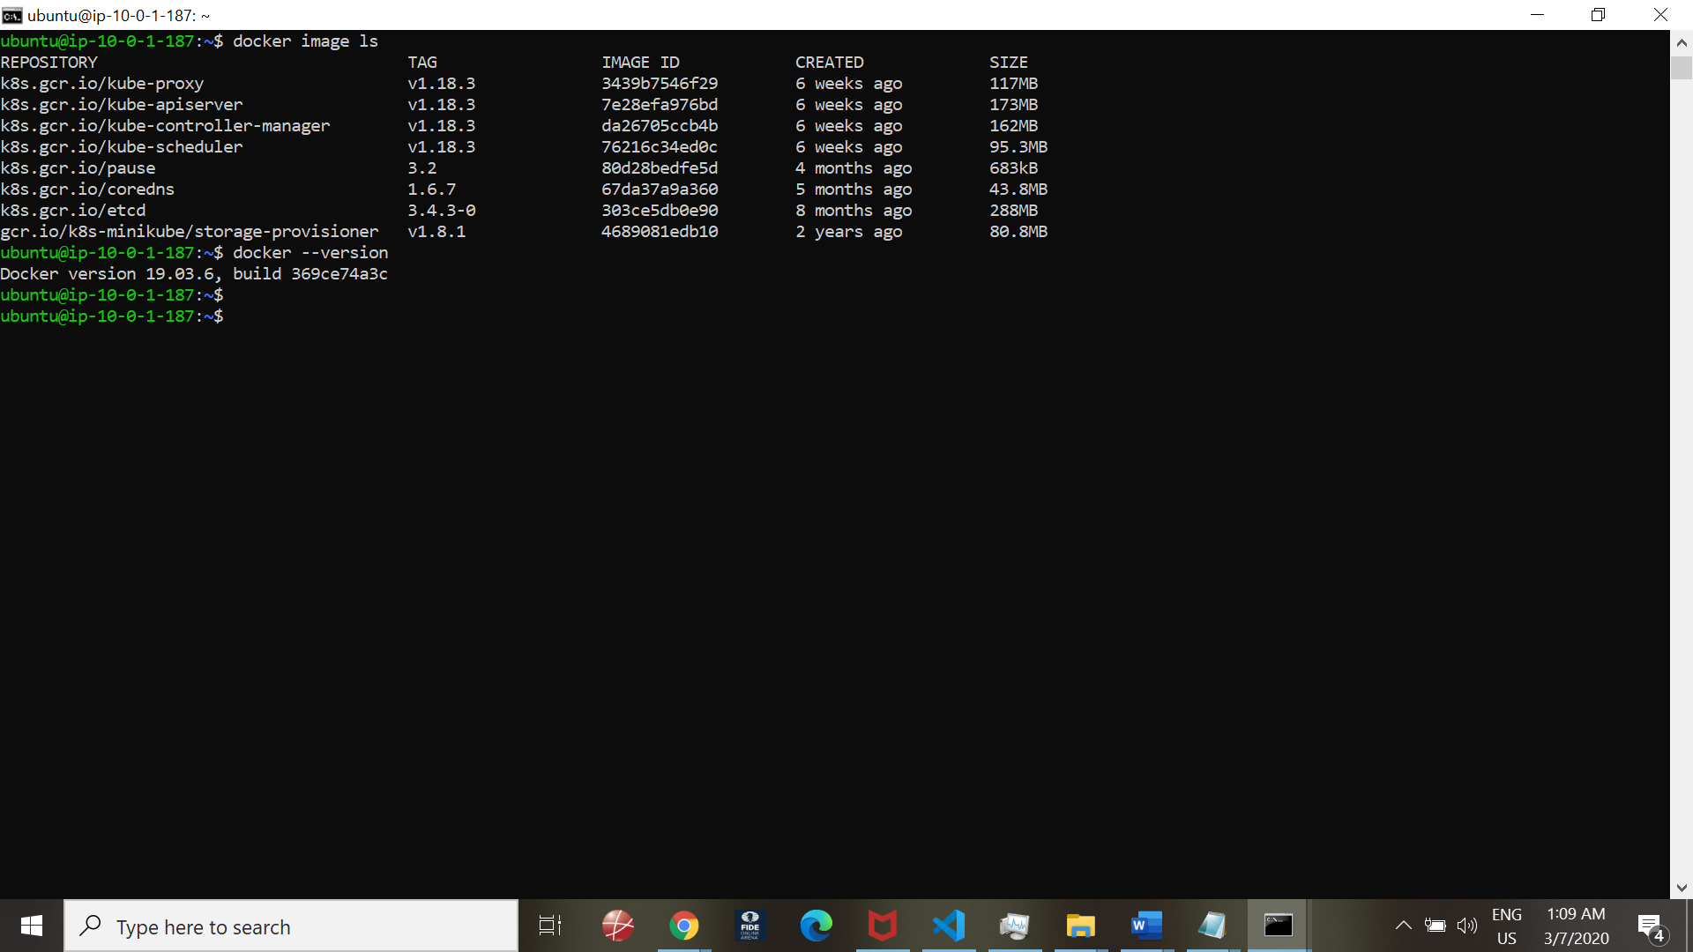

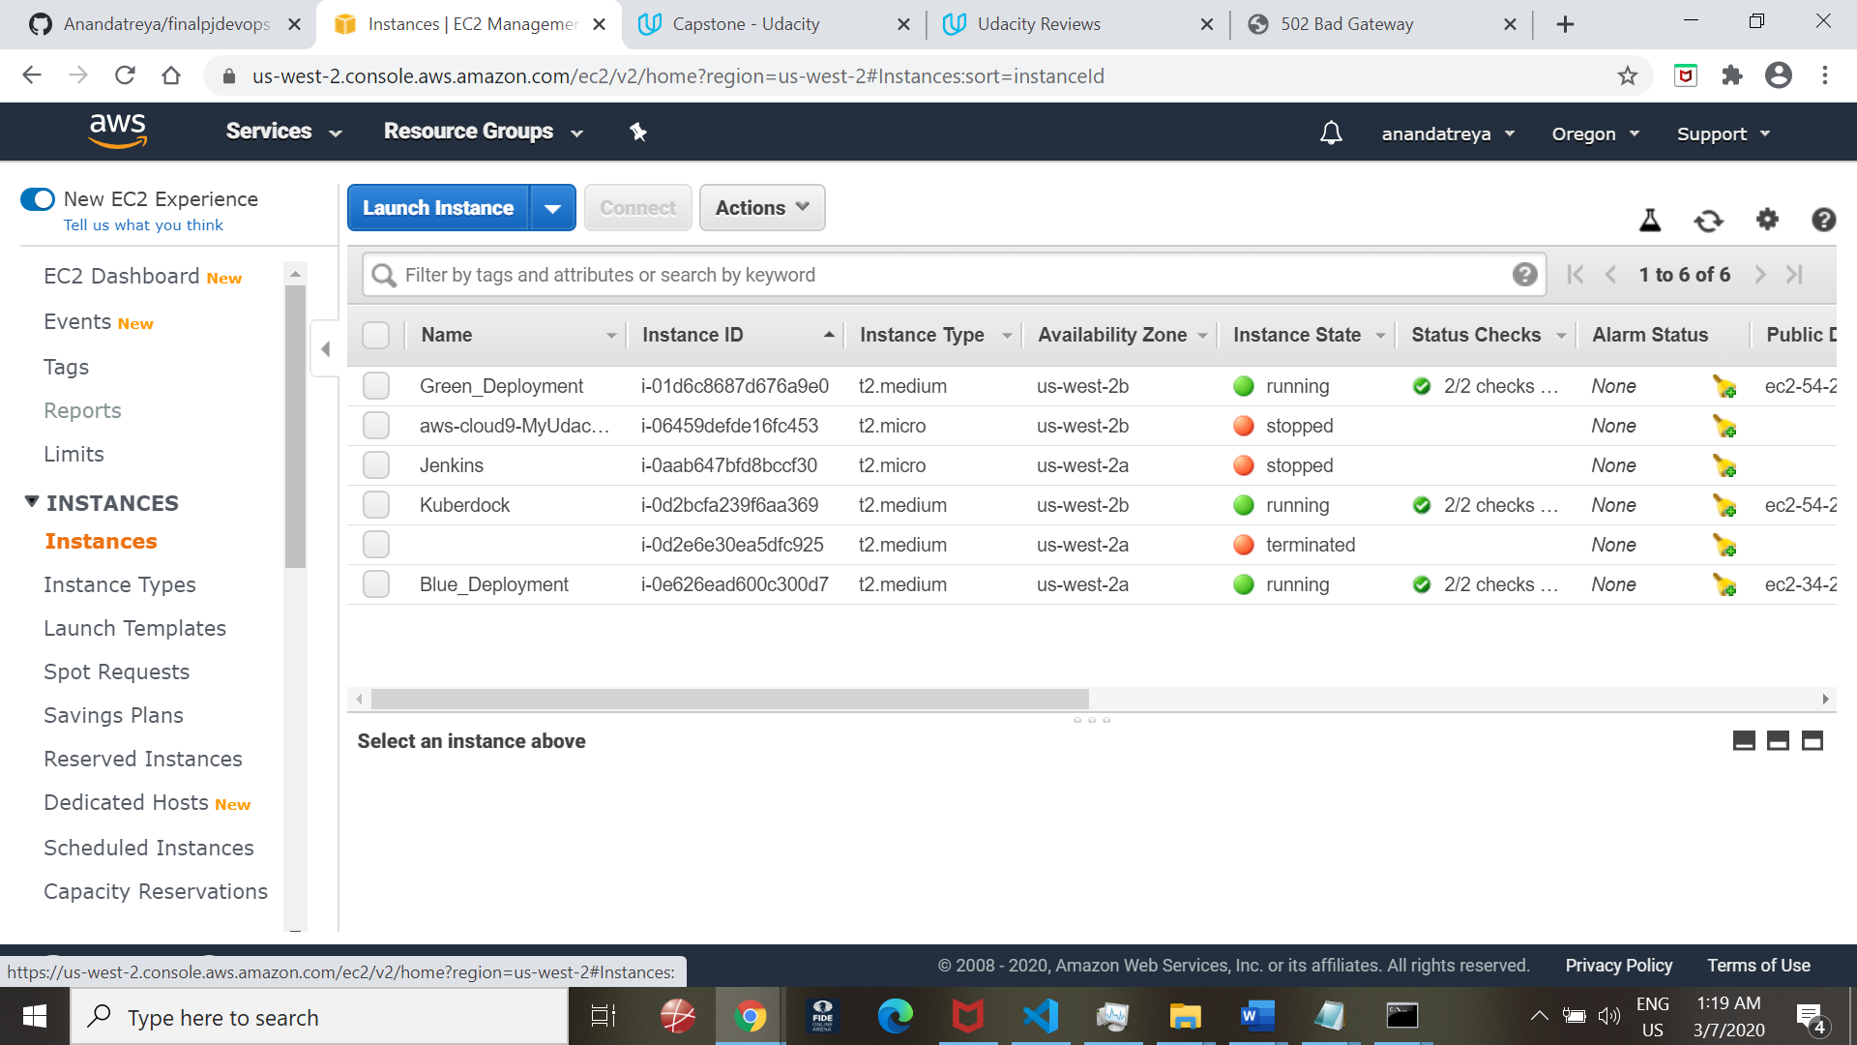

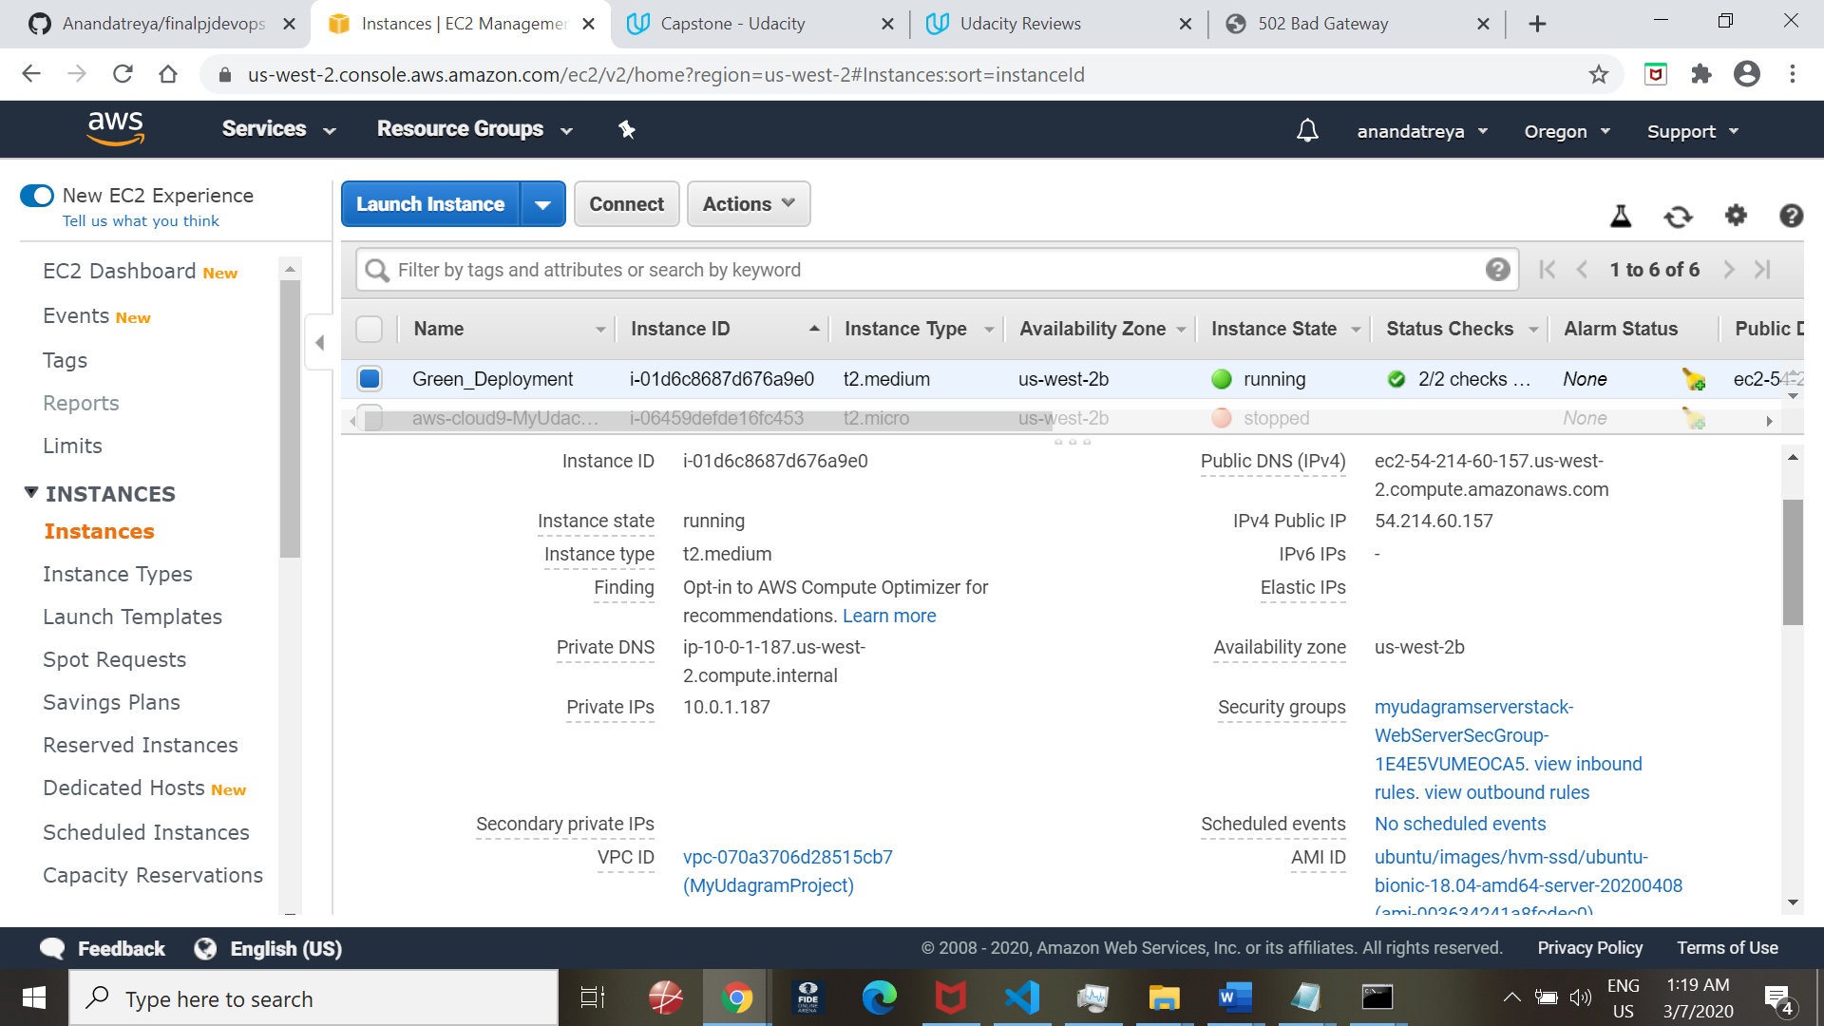

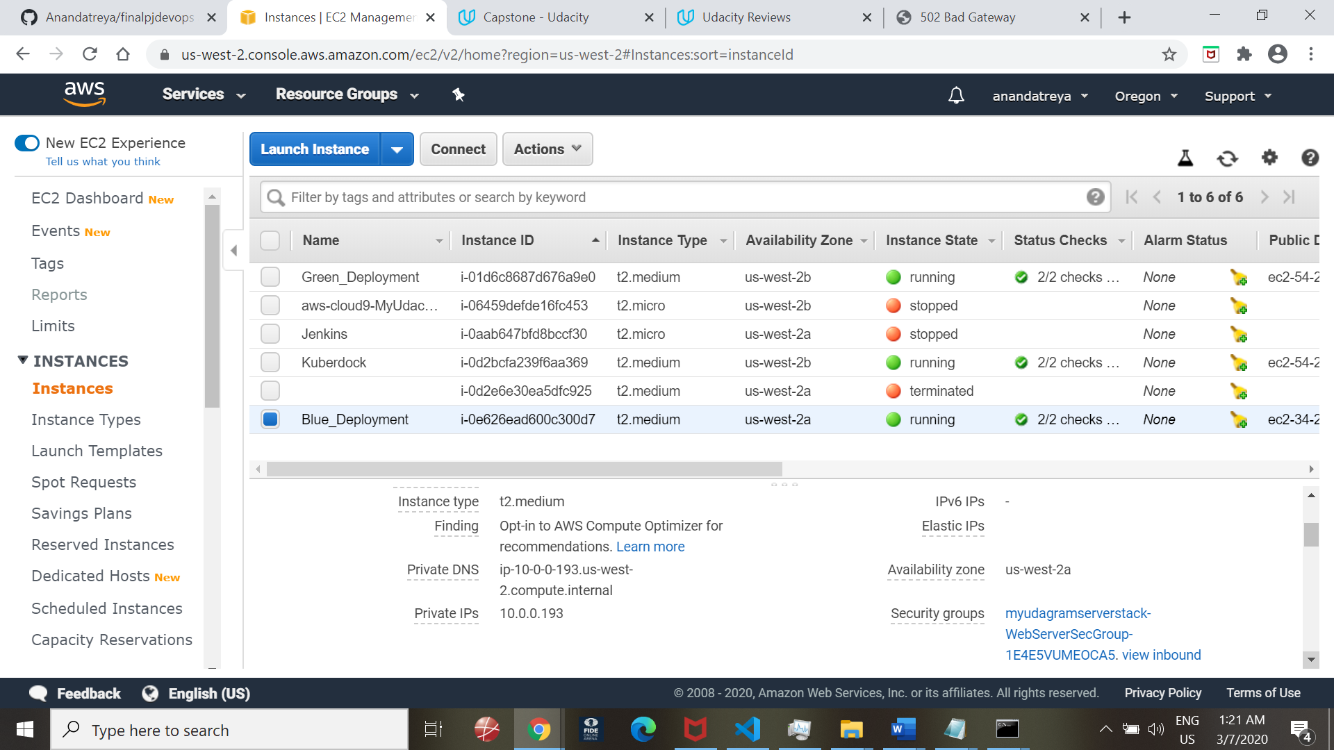

END--